

**TITLE : SECURITY OF PASSENGERS**

### Ministry:- Ministry Of Railways

### Problem Statement:- Passenger Security

### Team Leader Name:- Prathamesh Prasanna Dhavale

### Problem Code:- MOR2

**INDEX**

|  |  |  |
| --- | --- | --- |
| **Sr. No.** | **Title** | **Page Number** |
| **1.** | **Describe The Idea** | **3** |
| **2.** | **Solution** | **3** |
| **3.** | **Technology Stack** | **4** |
| **4.** | **Dependencies** | **5** |
| **5.** | **Language Support** | **5** |
| **6.** | **Use Case Diagram** | **6** |
| **7.** | **Prototype Of Application** | **6 - 9** |

**1.1 Describe The Idea:-**

Security of passengers and their belongings is of paramount importance for Indian Railways. We can provide the facility of direct call to the GRP and also facilitate voice message through our app. In case of any untoward incident or incident of crime against passengers and their belongings location will be shared with Government Railway Police at the next and previous Railway stations. So that GRP can take further actions. When any complaint is registered then GRP will send confirmation message.

**1.2 Solution:-**

We can make a mobile application that is all about the security of the people, especially for the women who travel by Indian Railway. If there is untoward incident or incident of crime against the passengers then the application will alert the nearest GRP at nearest Railway station, Security Control Room in case of any emergency, with just the press of a button.

Once the button on the app is pressed, the physical location (co-ordinates) of the victim will be sent to the GRP with the help of GPS and GPRS and the concerned police station will be able to track the user and ensure action on the same immediately. The FIR has particular format so details such as name, complaint, address, location, phone number, etc will be auto filled(from data stored on the database which will be entered by the user when he/she installs our app for the very first time) by our app so it will register the online FIR & the speedy initiation of action is taken by GRP.

If the emergency button is pressed by mistake then some kind of notification alert will be sent on screen and also some loud ringing sound will be played and there will be time duration of 30 seconds to cancel it before sending it to the GRP.

For any kind of emergency, another option will be provided of emergency calling i.e. dialing security helpline number “182” to directly connect to GRP via call.

Also we have added one more feature of sending voice message to the GRP rather than using the text message form which is a bit time consuming.

**2. Technology Stack:-**

* **Front End:**

**ANDROID:**

**a) JAVA.**

**b) XML**

Android provides a variety of pre-built UI components such as structured layout objects and UI controls that allow you to build the graphical user interface for your app. Android also provides other UI modules for special interfaces such as dialogs, notifications, and menus. Android apps are built as a combination of distinct components that can be invoked individually.



* **Back End:-**

**SERVER:**

1. **NODE-JAVASCRIPT EXPRESS**
2. **PHP**

* **DATABASE:** **MySQL**

At the time of installation of our app user will register their details and necessary information. This information will be stored with the help of MySQL Database.

**3. Dependencies:**

**Internet:**

In our project we are directly connecting passengers to the Government Railway Police(GRP). When the emergency button is pressed by passengers then their location will be shared with GRP and at the same time online FIR will be created. So, completion of this process requires minimum 200 kbps speed of internet which is provided by 3G network. Now a days 4G and 4G LTE networks gives 3 to 12 mbps speed of internet. While traveling in train passengers may have range problem. So, our app will work on minimum internet speed to complete over all process.

**GPS:**

In our project we will be sharing the exact location of the user with the GRP which will require the GPS navigation feature present in our smartphone.

**4. Language Support:**

* English(already developed)
* Hindi(in development stage)
* Marathi(in development stage)

We are going to release our app in multi-language support. We have already developed our prototype app with the ‘ENGLISH’ language and soon are going to be adding the Hindi and Marathi language support to it as the English language is not very common and understandable in rural areas.

**5. Use Case Diagram:-**

<<extend>>

<<extend>>

<<extend>>

Passenger GRP

<<extend>>

**6. Prototype of Application:**

App Name – ‘SAFE_YATRA’

We have already developed a very basic prototype android app of our solution to the problem statement given by the ministry of railways.

So far we have added only English language support and are soon going to add support for Hindi and Marathi language.

We have just given the front end to our app for now for just making the prototype and are developing the backend for the same.

The apk file of our app for testing or checking purpose can be found here -

[**https://drive.google.com/file/d/1jud7D8Fpgj1PeMe2keAN7IaTnzAUPBTH/view**](https://drive.google.com/file/d/1jud7D8Fpgj1PeMe2keAN7IaTnzAUPBTH/view)

In case you would like to check our code for the same prototype app, it can be found here on my ‘GITHUB’ profile, here is the link –

[**https://github.com/vikram7111997/Hackathon_SAFE_YATRA**](https://github.com/vikram7111997/Hackathon_SAFE_YATRA)

Here we are attaching a few screenshots of our app running in android studio emulator along side some code for your reference purpose.

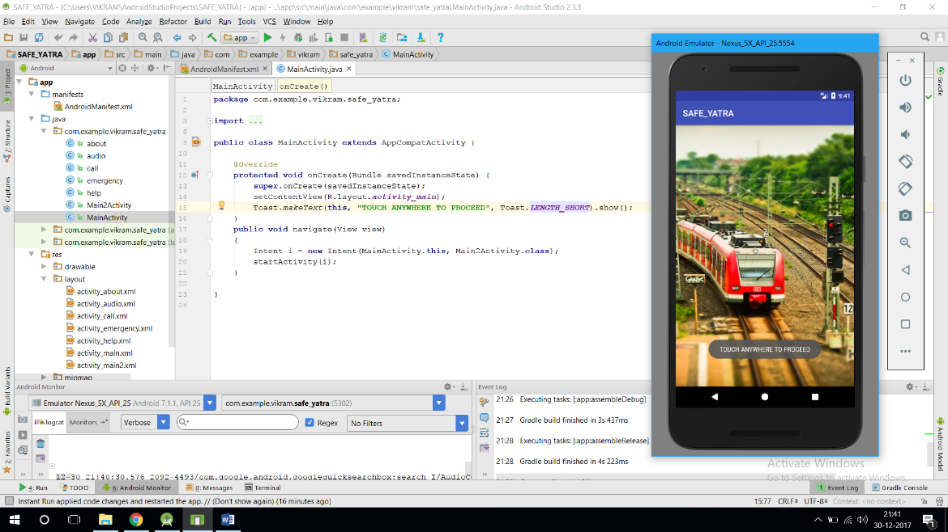

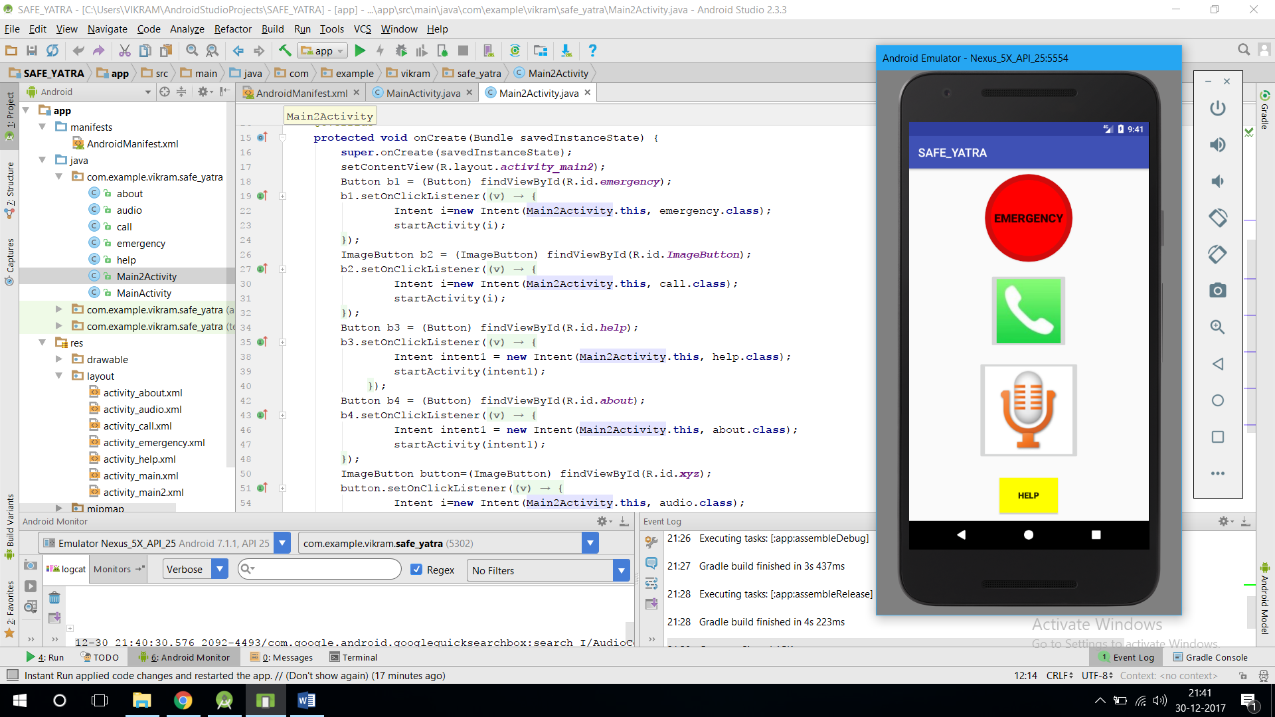

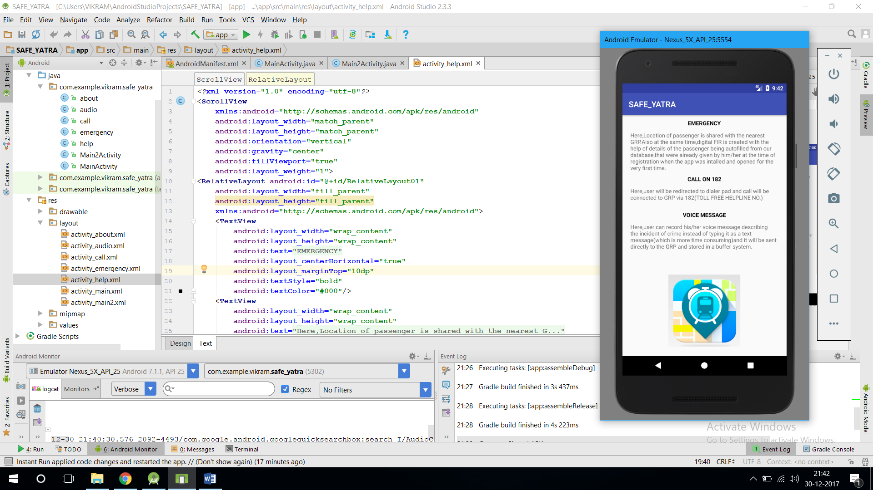

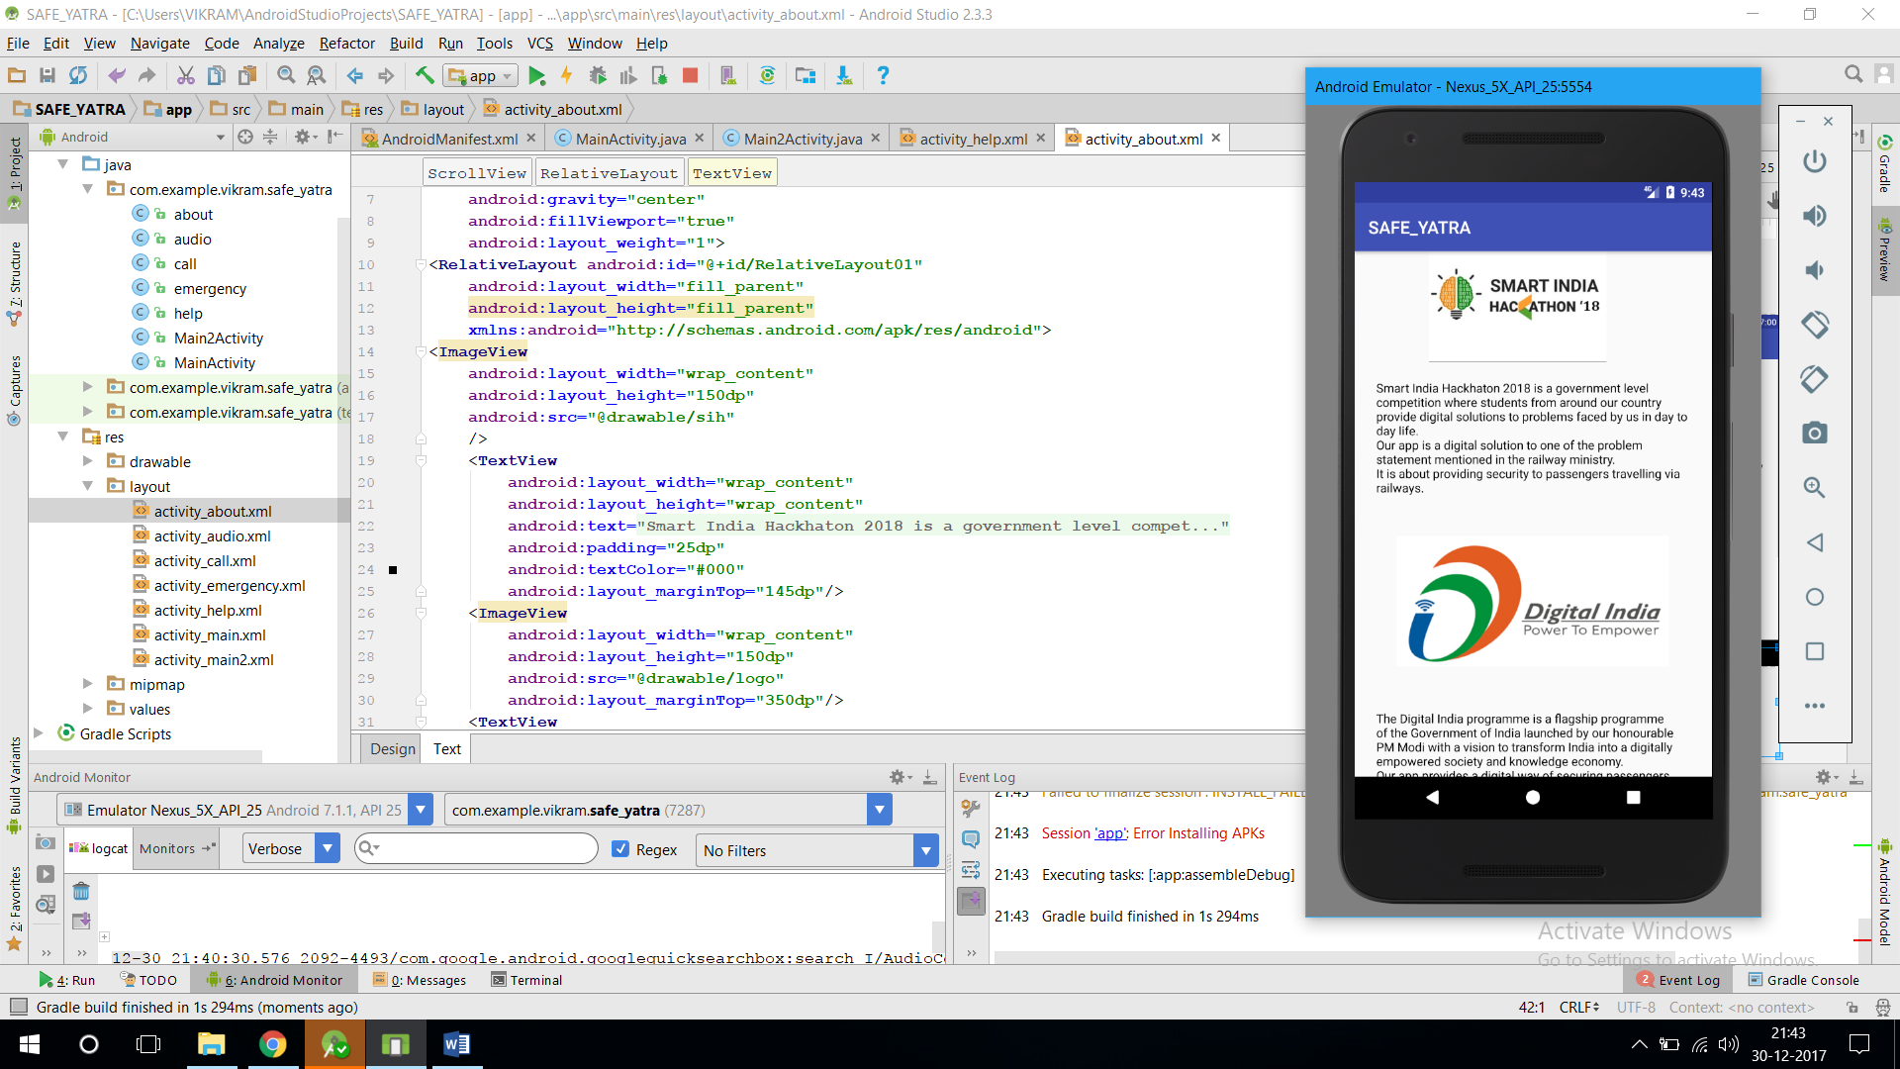

As already said the app is still in development stage and will be released with additional languages and backend support.